Incorporating HARMS into PSS

One challenge that every healthcare practitioner faces is that of organization and documentation in the EMR. One of the most widely used EMRs in Canada is Telus PSS. The team in Nipigon, the first satellite site of the HARMS Program, developed some tools to help incorporate the HARMS Program into the Telus PSS EMR. Here is a brief overview:

For new patients you can quickly enroll them into the HARMS Program and have this information stored into their respective charts using the below intake form.
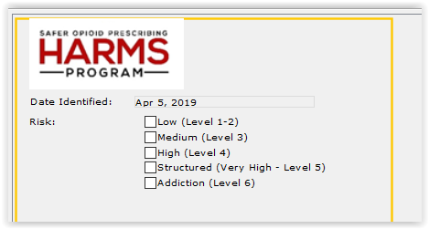
Once the patient is added via the intake form, a HARMS toolbar will appear at the top of their chart. It will identify 3 areas : RISK, UDT and Calls

RISK:
Firstly the toolbar reports the risk of your patient as cited by the user. The RISK flag is green if patient is level 1-2, yellow if level 3 and red if level 4, 5 or 6.In Risk, there is a MEQ (Morphine Equivalents) button. If an MEQ calculation has not been done or the opioid prescription has changed, the value beside MEQ in the toolbar will show ??. Clicking on the MEQ button will bring up the Medication Review page. This page summarizes their current opioid and non-opioid medications as well as their prior pain medications. Here you can update your patient’s medications, check-off if they have received a naloxone kit and monitor their medication with a pill counter. Below is an example of the page:
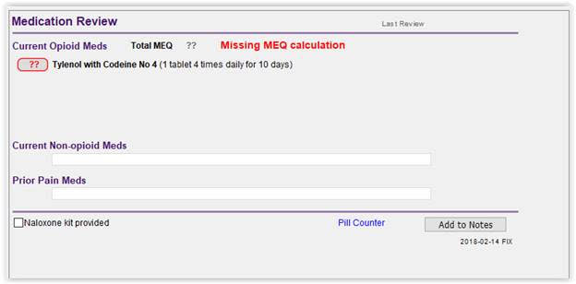
This test patient has Tylenol with Codeine No 4 in their prescription.. The user can click on the ?? outlined in red beside the medication to select dosages. Once accepted the MEQ is calculated and the toolbar is updated and looks like this:

Calls:
A large component of the HARMS program is the ongoing monitoring of patients. In the Calls section of the toolbar you can update monitoring information for your patient to help assess compliance or make decisions about changing future monitoring or prescribing practices. When contacting patients for screening, a window as shown below will appear after clicking on Calls.
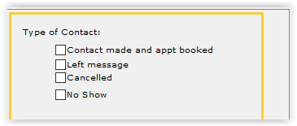
You will be prompted to select whether an appointment was made or a message was left for scheduling a new appointment. If an appointment was made and the patient cancelled or was a no-show, you can enter that information as well. The Calls section of the toolbar will update with information about the last call made to the patient and the status of the last call or appointment. Also the number of cumulative No Shows and Cancellations will be shown
This tells the physician that the last time the patient was called was Feb 1, 2019 and status of that call was a left message. To date, the patient had 1 no show and 1 cancellation.

UDT:
Once a patient has completed a UDT with the START-IT tool, the results and date will be automatically populated into the toolbar from the START-IT tool. The toolbar will automatically update with the cumulative number of UDTs completed to date. For the patient below, they gave a sample for UDT most recently on March 21, 2011 and that result was unexpected. They have done a total of 1 tests in the past.

If interested in adopting this tool, or with questions, we are grateful to Joyce Stansell - Quality Improvement Decision Support Specialist for numerous Northern Ontario Family Health Teams - who has agreed to making her contact available: jstansell@ndfht.ca. Joyce would be happy to facilitate sharing the HARMS Program tools they have created in Nipigon for PS Suite.

